Indian School Al Wadi Al Kabir
SAMPLE PAPER
COMPUTER SCIENCE (Code: 083)

Class : XII Time: 3 Hours
Max. Marks : 70

General Instructions:
- Please check this question paper contains 35 questions.
- The paper is divided into 4 Sections- A, B, C, D and E.
- Section A, consists of 18 questions (1 to 18). Each question carries 1 Mark.
- Section B, consists of 7 questions (19 to 25). Each question carries 2 Marks.
- Section C, consists of 5 questions (26 to 30). Each question carries 3 Marks.
- Section D, consists of 2 questions (31 to 32). Each question carries 4 Marks.
- Section E, consists of 3 questions (33 to 35). Each question carries 5 Marks.
- All programming questions are to be answered using Python Language only.

Q.No. | SECTION A | Marks
1 | State True or False  “A library in Python is a collection of various packages.” | 1
2 | Which of the following is a mutable datatype in Python?  (a) int (b) string (c) list (d) tuple | 1
3 | Which of the following is the output:  D={'a': 11, 'b': 22, 'c': 33, 'd': 44}  D.pop('b')  D['b'] = 22  print(D)  a. {'a': 11, 'c': 33, 'd': 44, 'b': 22}  b. {'a': 11, 'b': 22, 'c': 33, 'd': 44}  c. {'a': 11, 'c': 33, 'd': 44}  d. None of these | 1
4 | If all devices are connected to a central hub, then topology is called  a)tree topology b)bus topology c)star topology d)mesh topology | 1
5 | Which of the following options is the correct Python statement to read and display the first 14 characters of a text file "Notes.txt"?  (a) F = open('Notes.txt'); print (F.load (14))  (b) F = open('Notes.txt'); print (F. dump (14))  (c) F = open('Notes.txt'); print (F read (14))  (d) F = open('Notes.txt'); print (F.write(14)) | 1
6 | Look at the sequence and determine the output  >>> str="Program"  >>> str[:-1]  a. 'margorp'  b. 'Porm'  c. 'mroP'  d. 'Progra' | 1
7 | Fill in the blank:  command is used to add a column to a table in SQL.  (a) update (b)add (c) alter (d)insert | 1
8 | _________ is known as range operator in MYSQL.  a) IN  b) DISTINCT  c) IS  d) BETWEEN | 1
9 | Fill in the blank:  Candidate keys – alternate keys = __________________  - Primary Key  - Foreign Key  - Unique Key  (d) Different Key | 1
10 | To write data into CSV from python console, which of the following function is  correct?  a) csv.write(file) b) csv.writer(file)  c) csv.Write(file) d) csv.writerow() | 1
11 | is the clause to give conditions on groups.  a. Where  b. Having  c. Group by  d. Order by | 1
12 | Every network interface card(NIC) comes with its own….. address.  - Internet protocol  - DHCP  - MAC  - OSI | 1
13 | Evaluate the following:  16 // 3 + 3 ** 3 + 15 / 4 - 9  a. 27.75 b. 26.75 c. 30 d. 29.0 | 1
14 | The RDBMS terminology for a row is  (a) Tuple (b) relation (c) attribute (d) degree | 1
15 | To reflect the changes made in the database permanently you need to run ________  a)done()  b)reflect()  c)commit()  d)final | 1
16 | To execute all the rows from a result set, which method is used?  a) fetchall() b) fetchmany() c) fetchone() d) None of these | 1
Q17 and 18 are ASSERTION AND REASONING based questions. Mark the correct choice as
(a) Both A and R are true and R is the correct explanation for A
- Both A and R are true and R is not the correct explanation for A
- A is True but R is False
- A is false but R is True

17 | Assertion (A):- Local Variables are accessible only within a function or block in which it is declared.  Reasoning (R):- Global variables are accessible in the whole program. | 1
18 | Assertion(A): Python overwrites an existing file or creates a non-existing file  when we open a file with ‘w’ mode .  Reason(R) : a+ mode is used only for write operations | 1
 | SECTION B
19 | Rewrite the following code after removing syntax error:  Num=input(“Enter number”)  for i in range (1, Num)  if Num%i = 0 :  print Num*2  else:  print(Num*3) | 4
20 | Differentiate between FTP and HTTP.  OR  What is the difference between LAN and WAN? | 2
21 | - Given is a Python string declaration:  S="Preliminary Exam 2022"  Write the output of:  print(S[-2:2:-2])  b) What will be output of the following program:  L1 = []  L1.append([10,[20,33], 45])  L1.extend([17,80,95])  print(L1[0][1][1] + L1[2]) | 2
22 | Explain cross product with an example. | 2
23 | (a) Expand the following terms:  i) MAN ii) HTML  b) What is URL ? | 2
24 | Predict the output of the Python code given below:  def Execute(M):  if M%3==0:  return M*3  else:  return M+10;  def Output(B=2):  for T in range (0,B):  print(Execute(T),"*",end="")  print()  Output(4)  Output()  Output(3)  OR  Predict the output of the Python code given below:  The contents of a text file named ‘quote.txt’ is as shown below:  All the kings horses and all the kings men  cannot fix what isn’t broken.  What will be the output of the following code?  fin = open('quote.txt’)  data = fin.read(10)  print(data[0:3], end= ‘’)  data = fin.readline()  print(data[0:3] , end= ‘’)  fin.seek(0)  data = fin.read(6)  print(data[0:3] , end= ‘’) | 2
25 | Differentiate ORDER BY and GROUP BY with an example.  OR  Classify the following statements into DDL and DML  DELETE, SELECT, DROP, ALTER | 2
SECTION C
26 | Consider the following tables:  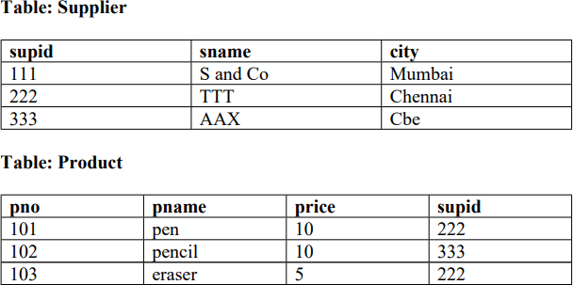  - Write any one point of difference between Equi join and Natural join.  - Find output:  - select *from product p, supplier s where p.supid=s.supid;  - select *from product natural join supplier;  OR  - Write a Query to insert House_Name=Tulip, House_Captain= Rajesh and House_Point=278 into table House(House_Name, House_Captain, House_Points).  - Write the output for SQL queries (i) to (iv), which are based on the table: STUDENT given below:  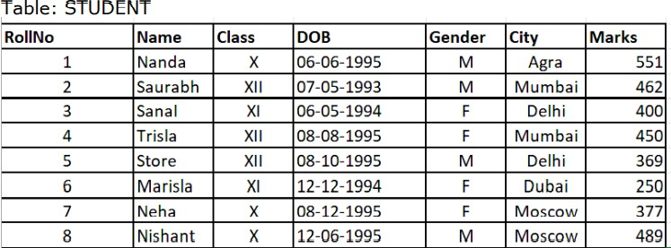  - SELECT COUNT(*), City FROM STUDENT GROUP BY CITY HAVINGCOUNT(*)>1;  - SELECT MAX(DOB),MIN(DOB) FROM STUDENT;  - SELECT NAME,GENDER FROM STUDENT WHERE CITY=”Delhi”;  - SELECT DISTINCT Class FROM STUDENT; | 1+2
27 | Write a Python program to count all the line having 'a' as last character  OR  Write a function in Python that counts the number of “the” or “this” words present in a text file “myfile.txt”.  Example  If the “myfile.txt” contents are as follows:  This is my first class on Computer Science. File handling is the easiest topic for me and Computer Networking is the most interesting one.  The output of the function should be: Count of the/this in file: 3 | 3
28 | a. Write SQL commands for the queries (i) to (iii) and output for (iv) & (v) based  on a table COMPANY and CUSTOMER .  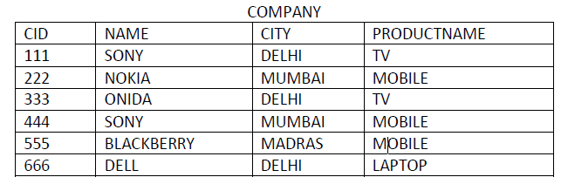  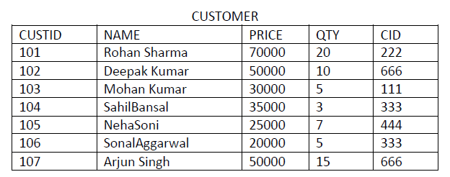  (i) SELECT PRODUCTNAME,CITY, PRICE FROM COMPANY,CUSTOMER  WHERE COMPANY.CID=CUSTOMER.CID AND  PRODUCTNAME=”MOBILE”;  (ii) SELECT AVG(QTY) FROM CUSTOMER WHERE NAME LIKE “%r%;  (iii) SELECT PRODUCTNAME, C2. NAME FROM COMPANY C1,  CUSTOMER C2 WHERE C1.CID = C2.CID AND PRICE <30000; | 3
29 | Write a function EVENLIST(L), where L is the list of elements passed  as argument to the function. The function returns another list named “ELIST’ that contains all even position elements ending with 7 from the list L.  For example:  If L contains [2,17,27,9,7,10,17,37]  The ELIST will have [27, 7, 17] | 3
30 | A list student contains the following record of student with the following format: [rollno,name,mark]  Write separate user defined functions to perform the following operations:  - Push(student) – to add the Name of the students into the stack whose mark is more than 80  - Pop() – to remove and display the content of the stack. Also, display “Stack Empty” when there are no elements in the stack. | 3
SECTION D
31 | Write the output of the SQL queries (a) to (d) based on the table TRAVEL  given below :  Table : TRAVEL  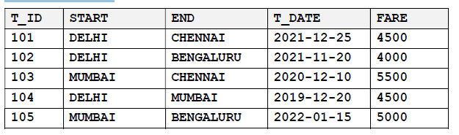  1. What is the suitable datatype of the column START  2. What is the cardinality and degree of the table?  3. Write the statements to :  a. Delete the details of train from Mumbai to Chennai.  b. Increase the fare of all Delhi train by 500.  OR  3. Write the statement to:  a. Delete the column t_date.  b. Insert a following record  ( 106, “ CHENNAI”, “MUMBAI”, 2022-09-23”, 5000) | 4
32 | Sam has written a code and created a binary file bank.dat custid, custname , acctype and balamt. The file contains 10 records. He now has to update a record based on the custid entered and update the balamt. If the custid is not found, an appropriate message should to be displayed. As a Python expert, help him to write a code based on trequirement. | 4
 | SECTION E
33 | “Ujjwal Patra” an NGO is planning to setup its new campus at Pondicherry for its  Web-based activities. The campus has four (04) UNITS as shown below:  Distance between above UNITs are given below:  Admin Training 65 m  Admin Resource 120 m  Admin Finance 100 m  Finance Training 60 m  Finance Resource 40 m  Training Resource 50 m  No. of Computers in various UNITs are:  Units No. of Computers  Admin 150  Finance 25  Training 90  Resource 75  (i) Suggest an ideal cable layout for connecting the above UNITs.  (ii) Which network device is used to connect the computers in all UNITs?  (iii) Suggest the placement of Server in the UNITs of above network.  (iv) NGO is planning to connect its Regional Office at Chennai, Tamilnadu.  Which out of the following wired communication, will you suggest for a  very high-speed connectivity?  (a) Twisted Pair cable (b) Ethernet cable (c) Optical Fiber  (v) Suggest a device/software to be installed to take care of data security. | 5
34 | What are the characteristics of csv file ?  Write a Program in Python that defines and calls the following user defined functions:  (i) ADD_PROD() – To accept and add information about a product into a csv file named ‘product.csv’. Each record consists of prodno, prodname and price to store product no , product name and price of the product  (ii) DISPLAY_PROD() – To display details of products having price more than 100, present in the CSV file named ‘product.csv’.  OR  When do we use csv file?  Write a Program in Python that defines and calls the following user defined functions:  (i) insert_roll()– To accept and add data of a student to a CSV file ‘marks.csv’. Each record consists of a list with field elements as rollno, mark to store roll number and mark of students respectively.  (ii) read_roll()- To find and return the average mark of students. | 1+4=5
35 | i) Define the term Domain with respect to RDBMS. Give one example to support your answer.  (ii) Kabir wants to write a program in Python to insert the following record in the table named Student in MYSQL database, SCHOOL:  - rno(Roll number )- integer  - name(Name) – string  - DOB (Date of birth) – Date  - Fee – float  Note the following to establish connectivity between Python and MySQL:  - Username – root  - Password – tiger  - Host - localhost  The values of fields rno, name, DOB and fee have to be accepted from the user. Help Kabir to write the program in Python.  OR  (i) Give one difference between alternate key and candidate key.  (ii) Sartaj has created a table named Student in MYSQL database, SCHOOL:  - rno(Roll number )- integer  - name(Name) – string  - DOB (Date of birth) – Date  - Fee – float  Note the following to establish connectivity between Python and MySQL:  - Username – root  - Password – tiger  - Host – localhost  Sartaj, now wants to display the records of students whose fee is more than 5000. Help Sartaj to write the program in Python. | 1+4=5

********************************************************

